**PRACTICE PROBLEM 07.08.2024**

1. import java.util.regex.*;

public class main{

public static void main(String[] args){

String str="ababccabcbc";

Pattern p=Pattern.compile("ab");

Matcher m=p.matcher(str);

while (m.find()) {

System.out.println("Found at index: " + m.start());

}

}

}

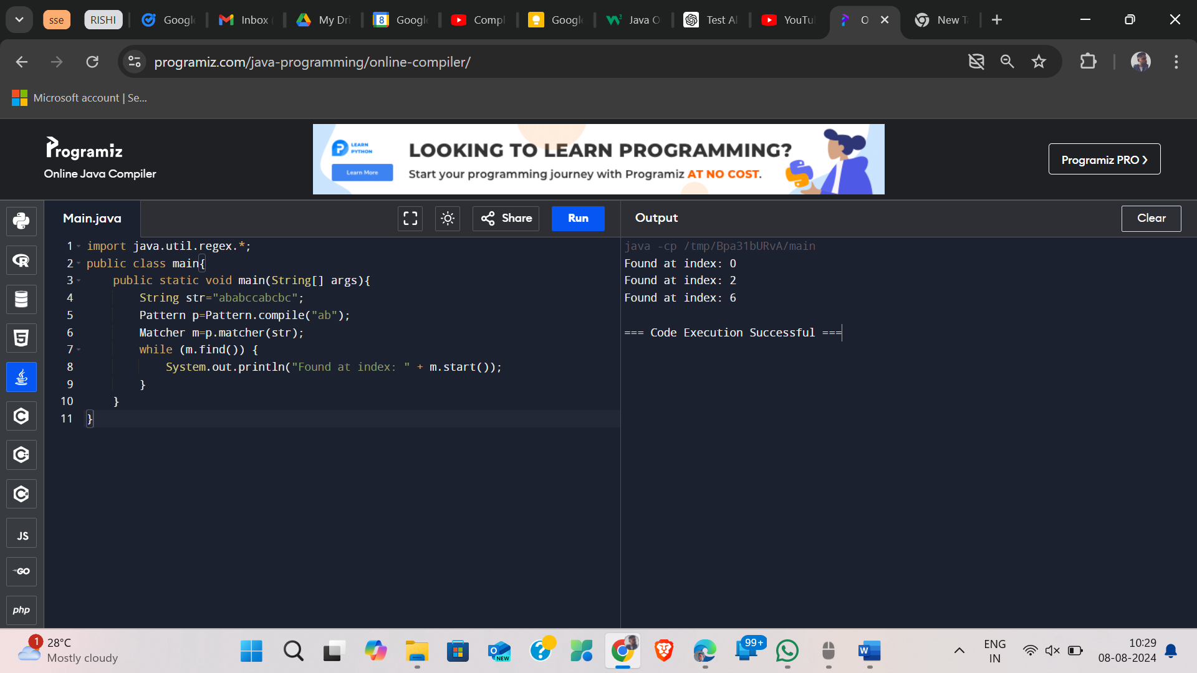

2) import java.util.regex.Pattern;

import java.util.regex.Matcher;

public class PatternSearch {

public static void main(String[] args) {

String patternString = "ab";

String inputString = "ababcabccabcbc";

Pattern pattern = Pattern.compile(patternString);

Matcher matcher = pattern.matcher(inputString);

while (matcher.find()) {

int startIndex = matcher.start();

String matchedSubstring = matcher.group();

System.out.println("Pattern \"" + matchedSubstring + "\" found at index " + startIndex);

}

}

}

3)

import java.util.regex.Pattern;

public class string {

public static void main(String[] args) {

String a = "tamil tamilnadu tamil";

Pattern p = Pattern.compile("\\s");

String[] st2 = p.split(a);

for (String r : st2) {

System.out.println(r);

}

}

}

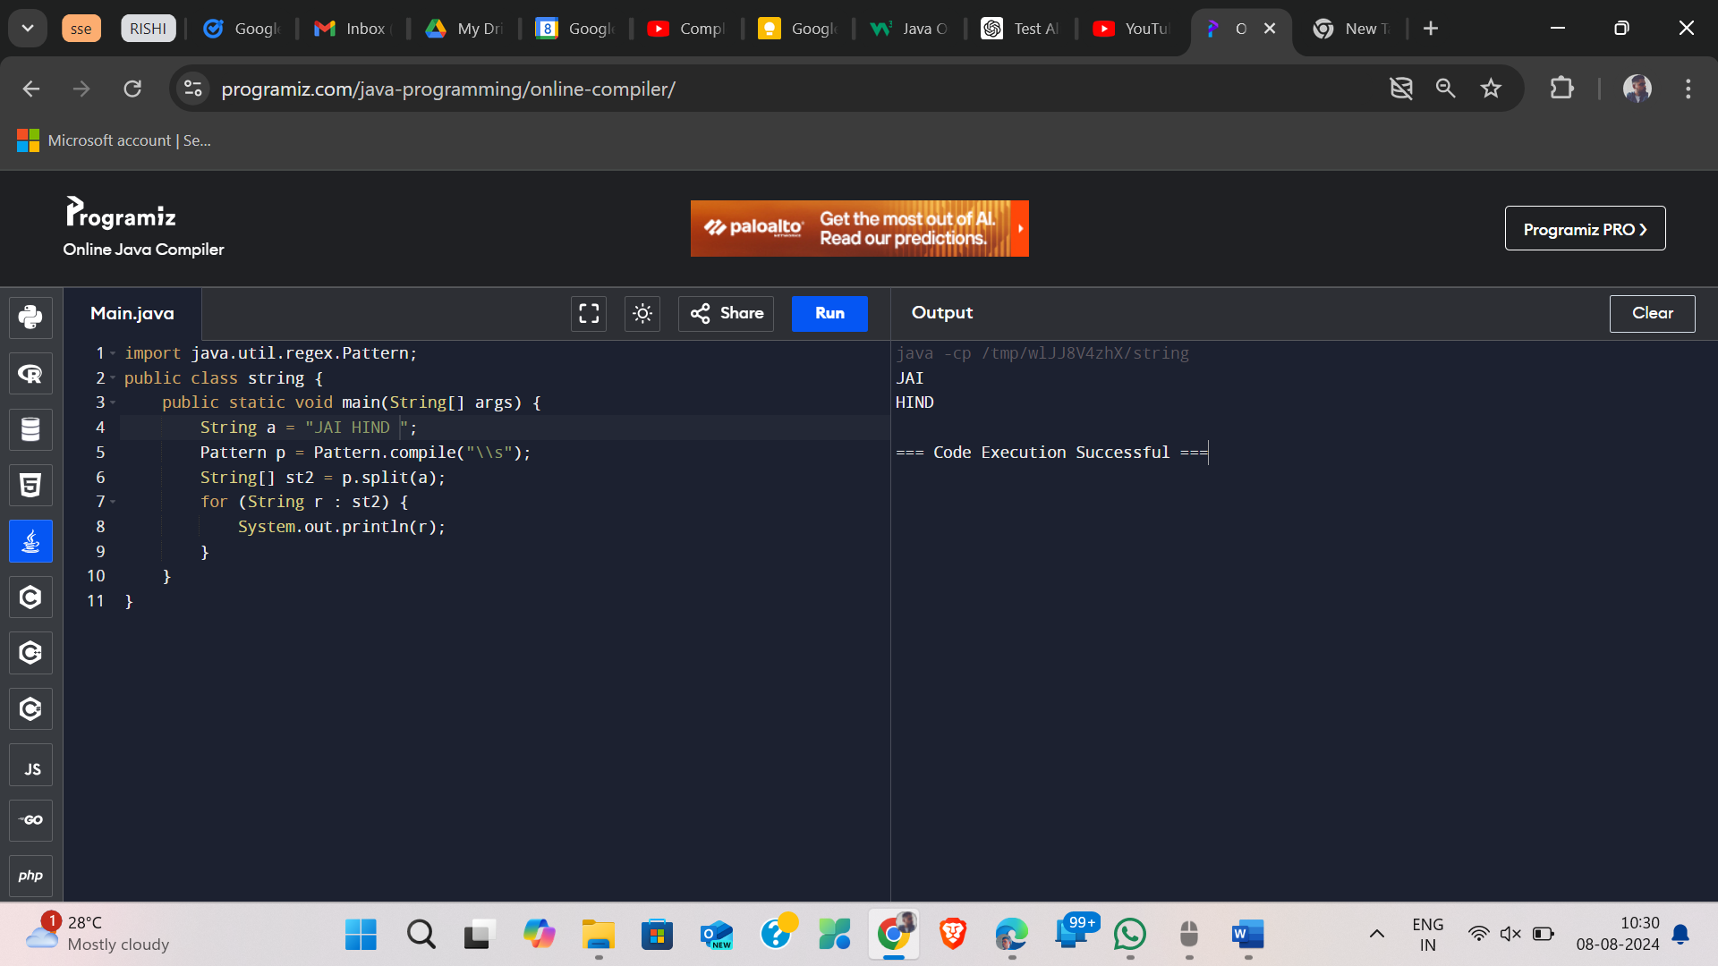

4)

import java.util.regex.Matcher;

import java.util.regex.Pattern;

public class RegexQuantifiersExample {

public static void main(String[] args) {

String input = "aaaaabbbcccdde";

Pattern pattern1 = Pattern.compile("a*b");

Matcher matcher1 = pattern1.matcher(input);

while (matcher1.find()) {

System.out.println("Found match with '*': " + matcher1.group());

}

Pattern pattern2 = Pattern.compile("a+b");

Matcher matcher2 = pattern2.matcher(input);

while (matcher2.find()) {

System.out.println("Found match with '+': " + matcher2.group());

}

Pattern pattern3 = Pattern.compile("a?b");

Matcher matcher3 = pattern3.matcher(input);

while (matcher3.find()) {

System.out.println("Found match with '?': " + matcher3.group());

}

Pattern pattern4 = Pattern.compile("a{5}");

Matcher matcher4 = pattern4.matcher(input);

while (matcher4.find()) {

System.out.println("Found match with '{5}': " + matcher4.group());

}

Pattern pattern5 = Pattern.compile("a{3,}");

Matcher matcher5 = pattern5.matcher(input);

while (matcher5.find()) {

System.out.println("Found match with '{3,}': " + matcher5.group());

}

Pattern pattern6 = Pattern.compile("a{2,4}");

Matcher matcher6 = pattern6.matcher(input);

while (matcher6.find()) {

System.out.println("Found match with '{2,4}': " + matcher6.group());

}

}

}

